An evaluation of my progress throughout the project.  
And what I think I need to do to improve.

Throughout the project, I have completed many of the tasks provided to me.

Sadly, I didn’t quite finish the website.

I have completed:

* The site-map
* The visualization
* The report on legal restrictions
* The asset table
* The home page
* The test table

I started working on, but didn’t complete:

* The acts page
* The client requirements questions

And, finally, I didn’t do:

* The tickets page
* The environment page
* The contact page

For my next project, I should focus more on getting the actual website finished, rather than the other files required for the project – do the important parts of the project first.

I feel that I have not met the brief due to the lack of actual website. I prepared assets for all of the requested pages, other than the recycling page. I worked too hard on the irrelevant things, when I should have focused on the task at hand.

I was asked to make an acts page, and I only managed to partially do so. The custom styling for the page was missing almost completely, except from the back button. I needed to style the display for all of the bands, but I didn’t get around to it.

I also missed out many other key things I was asked to create – a tickets page, an environment page (explaining their recycling initiatives, etc.), and a contact page. Clients don’t pay for incomplete websites.

I successfully made a home page, with navigation embedded within the introductory paragraph. When entering other pages, there is no navigation bar – you have to just use the back button to return to the home page. I made this decision as I didn’t want to clutter the pages as much as possible to keep my design minimalistic.

I am rather happy with how the home page came out compared to the design, it is rather accurate; however, it could do with some fine tuning.

The home page

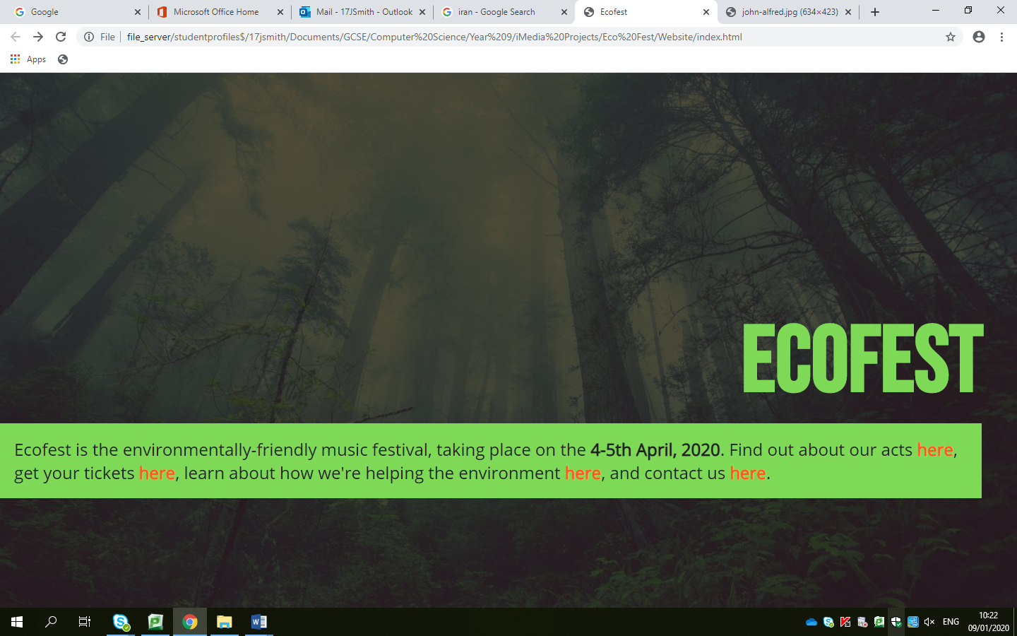

The original design  
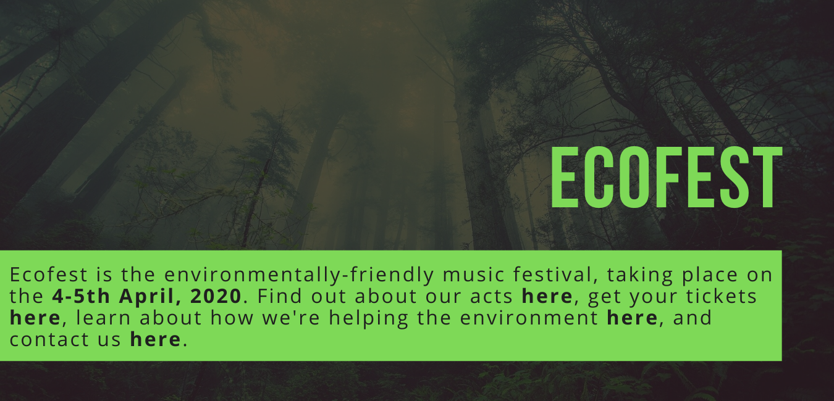

Throughout the pages I have managed to keep a rather consistent design. I chose my colour scheme thinking about the environment, finally coming out with my main colours being green and black.

My back button would be in the same place on every page that I would’ve made, so it would be easy to return back to the home page to navigate to another page if a user would wish to.

I could have also improved by adding JavaScript functionality and making the website more interactive – which I was planning but never got around to.

In short, I need to make the website – not word documents or PowerPoint presentations, and I need to think about working more efficiently – otherwise I won’t get anywhere.